 **5 Dec 2014** **The Weekly Bulletin of Rotary Club of Kathmandu Mid-Town** **bc-22/11.014**

|  |
| --- |
|  |

District: 3292 Web:www.rotarymidtown.org.np Club Id: 26776

**DECEMBER IS THE ROTARY FAMILY MONTH**

**Rotarians, clubs, and districts worldwide are encouraged to demonstrate their**

**commitment to family and community through projects, activities, and events in**

**celebration of Family Month each December.**

Club’s Regular Weekly Meeting : Friday, 28 November :

Extracts of the Meeting Minutes are given below:

“1. Meeting # 1256 was called to order at 8:00 AM by President Kul.

“8. Guest Speaker Rtn Peter Von Gunten talked about Creating Opportunities in Health, Education & Business. He talked

about wireless Nepal, opportunities in E-Health, Tele Education, E-Learning, E-Libraries. He spoke about his interest in

doing Rotary Global Grant Projects in Nepal. He said his team is already working with Rotaries – Pokhara Midtown,

Pokhara, Pokhara New Road and Parbat Rotary.

“9. PP Giri, Rtn Govinda & Rtn Shankar took part in the discussion. President Kul said, “there is opportunities for us to

collaborate.”

“10. PP Komal informed that RC Ktm Midtown is always full of service grants. RC Ktm Midtown just completed one VTT

on education. He also spoke about ANM project that is going to be closed.

“11. Information sharing:

> President Kul informed that anyone still needing to clear the bill for guests and friends who attended the Charter Day

dinner remit to Dr Dahal at earliest convenience.

> President also informed that CD of all photos taken by a professional photographer on the occasion of our 25th

Charter Day Celebration is on sale now (for 300 Nrs). Pls see Mr Dahal..

> Trip to Rara – site visit on the occasion of the closing of the ANM Project. Proposed dates Dec 12-14 – leaving right

after the meeting on Dec 12th. Please confirm ASAP for booking air tickets and arranging other logistics.

“12. Statistics of the meeting: Members present: 17”.

# Weekly Meetings and Programs :

|  |  |  |
| --- | --- | --- |
| Date | Program/Speaker | Topic of Presentation |
| 5 December | Inspector Dipak Bhandari /  Dy Sub- Inspector Jyoti Thapa | History and Use of Polygraph in Nepal |
|  |  |  |
|  |  |  |

Friday, 5 December:

**Inspector Dipak Bhandari / Dy Sub- Inspector Jyoti Thapa** of Nepal Police (Polygraph Unit) will be our Guest Speakers on 5 December Friday meeting. They will be giving a brief talk on history and use of Polygraph in Nepal.

Inspector Dipak Bhandari is a Certified Polygraph Examiner and works as the Certified Polygraph Quality Control Officer in Nepal Police. He is also a member of American Polygraph Association. He did his Master in Public Administration, and bachelor degree in law and arts faculties. He has eight years of law enforcement experience in Nepal Police.

Dy Sub- Inspector Jyoti Thapa, also a member of American Polygraph Assoociation, is a Certified Polygraph Examiner. She has altogether eight years of law enforcement experience with one year of polygraph examiner in Nepal Police.

**RI Convention : Sao Paulo**

**Registration fees**

Deadline 1: 15 Dec 014 Deadline 2: 31 Mar 015 After 31 March

Rotarian, spouse, guest or RC employee $ 325 $ 375 $ 425

Rotaractor or guest $ 70 $ 100 $ 130

Interactor, guest age 5-18 $ 10 $ 10 $ 10

*Source: Rotary International*

You missed it !

ROTARY FELLOWSHIP ‘N WALKING

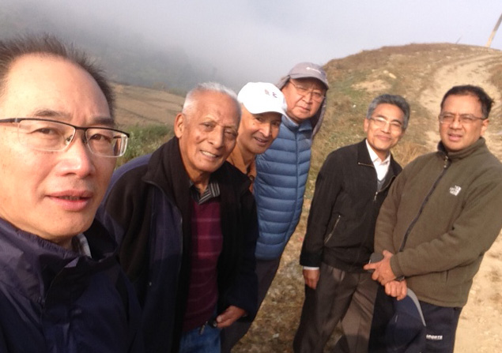

Six walking enthusiasts - PPs Giridhar, William, Ajaya, Arun, Komal, and Rtn Dr Rabindra - kick started the popular Saturday Weekend walk last week. The walk from Khokana on the southern outskirt of Kathmandu Valley took them through freshly harvested rice fields, bucolic rural setting and through the Shitali temple. They enjoyed the fellowship on a nice bright Saturday morning.

PP Giridhar hosted a sumptous breakfast!

**Anyone (CM) interested can join this group this Saturday.**

**Four polio workers gunned down in Quetta**

Gunmen attacked a polio vaccination team recently in the southwestern city of Quetta, killing four health workers, officials said. The vaccination team of three women and three men was waiting for a police escort when two gunmen opened fire on them.

Local militants oppose the vaccination campaign, alleging that western governments use it as a cover to spy on insurgents. A Pakistani used the same method of a fake vaccination drive to collect evidence on al-Qaeda’s late chief Osama bin Laden, which led to his killing by a US special forces team in a compound in the Pakistani city of Abbottabad. Pakistan is one of only three countries in the world where polio remains endemic. The incidence of polio in Pakistan has hit a 15-year high: **the World Health Organization has alrlealdy registered 235 polio cases** since January. Attempts to administer the vaccine have been hindered by militant attacks that have killed hundreds of health workers.

*Source: The Himalayan Times*

**Committee Chairs’ Column:** *(This column is for use by chairpersons of 5 permanent committees: Club Administration, Membership, Public Relations, Service Projects, and the Rotary Foundation)*

Travel and Tourism

.*Source: Internet*

**World AIDS Day** **:** **1 December**

“On this World AIDS Day, I call on world leaders to unite in our common cause. We have started to turn the tide. We have set a bold target. Let us end AIDS together by 2030.” *- Secretary-General Ban Ki-moon*

The 2014 theme for World AIDS Day is “Focus, Partner, Achieve: An AIDS-free Generation.”

**UNAIDS Strategy 2011-2015 :** The [UNAIDS strategy](http://www.unaids.org/sites/default/files/en/media/unaids/contentassets/documents/unaidspublication/2010/JC2034_UNAIDS_Strategy_en.pdf) aims to advance global progress in achieving country set targets for universal access to HIV prevention, treatment, care and support and to halt and reverse the spread of HIV and contribute to the achievement of the Millennium Development goals by 2015.

Adopted by the Programme Coordinating Board in December 2010, the strategy works to position the HIV response in the new global environment. The AIDS response is a long term investment and the intent of the strategy is to revolutionize HIV prevention, catalyse the next phase of treatment, care and support, and advance human rights and gender equality.

*Source: Internet*

**International Day of Persons with Disabilities : 3 December**

"Let us spare no effort to ensure that policies, programmes, guidelines and 21st century technologies are accessible to persons with disabilities, and sensitive to their perspectives and experiences." *- Secretary-General Ban Ki-moon*

The International Day of Persons with Disabilities is marked around the world annually on 3 December, as per General Assembly resolution of 14 October 1992, to promote awareness and mobilize support for critical issues pertaining to the inclusion of persons with disabilities in society and development.

**Theme for 2014:** Sustainable Development: The Promise of Technology

With an estimated one billion people worldwide living with a disability, and 80% of them living in developing countries, access to technology is key to help realise the full and equal participation of persons with disabilities. Under the theme of “Sustainable Development: The promise of technology”, this year’s International Day of Persons with Disabilities will look at this issue in the context of the post-2015 development agenda.

*Source: Internet*

**International Volunteer Day : 5 December**

"Today, we are highlighting the millions of young volunteers around the world who are acting globally for social change."

*- Secretary-General Ban Ki-moon*

International Volunteer Day offers an opportunity for volunteer organizations and individual volunteers to make visible their

contributions - at local, national and international levels - to the achievement of the [Millennium Development Goals](http://www.un.org/millenniumgoals/).

Apart from mobilising thousands of volunteers every year, the [United Nations Volunteers](http://www.unv.org/)  programme works closely with partners and governments to establish national volunteer programmes to create structures that foster and sustain local volunteerism in countries. Through the [Online Volunteering service](http://www.onlinevolunteering.org/en/index.html) volunteers can take actin for sustainable human development by supporting the activities of development organizations over the Internet. Every day thousands of people are volunteering, online or on-site, contributing to peace and development and working to achieve the MDGs.

*Source: Internet*

**Members’ Corner:** *(This column is for Club members to express anything they would like in matter of Club activities, Club administration, Club issues or on Breakfast Chatter, or on anything else that would be of interest to fellow members.)*

Militants’ attack on polio vaccination team in Pakistan:

Our District could probably coordinate with RI district in Pakistan to design and launch awareness programs particularly addressed to militant groups on PolioPlus and Rotary’s involvement.

Our Club could possibly take some initiative on this ! This is just an idea.

On Lighter Side :







*Courtesy: Rtn Isabella Khadka*

**A THOUGHT FOR TODAY:**

**The truth isn't always beauty, but the hunger for it is.**

 - Nadine Gordimer, novelist, Nobel laureate (1923-2014)

*Courtesy: Rtn Isabella Khadka*

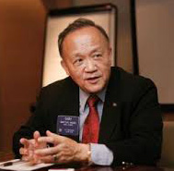

I feel especially honored when I am invited to share in club celebrations. To me, taking part

in a Rotary club celebration as Rotary International president is like being invited to a family

event as an honored guest. Indeed, Rotary is the biggest family in the world.

**RI President GARY C.K. HUANG**

Please send information on club activities, progress reviews on service projects, relevant photos etc to:

BC Editor: RR Shrestha email: rryesrr@gmail.com

## 5 December 2014 The Weekly Bulletin of Rotary Club of Kathmandu Mid-Town bc-22/12.014

*******************************